Fun-fun “tree” activity:
You can choose two options:
- Track your exciting day, or...
- “Dem Bones”: Music and your skeleton
Based on your choice, try to implement one of the following:
The “node”:
Like the linked list, the key item in the tree (or graph) structure is a “node”. With the linked list, the node basically contains:
- The data you are storing
- Pointers (links) to other nodes
- (Maybe some other things, like with “red-black” tress, where there’s some internal stuff that’s also in there to help organize things)
Recall that a doubly linked list node would look something like this:
class cNode {
cNode* pPrevious;
cNode* pNext;
cWhatever theData;
};
If you have a binary tree, then you need something almost same, except that there’s 3 pointers:
cNode* pParent;
cNode* pLeftChild;
cNode* pRightChild;
Just like the linked list, having a 0/NULL/nullptr means that “there isn’t a node”.
So:
- If the node was at the “root”, then the pParent would be pointing to NULL.
- If the node was a “leaf” node, then the “children” are pointing to NULL.

Keep in mind that binary trees are just one kind of tree, not the “only” kind, so for this assignment, you can set up something simple like this, where we store the child nodes as an array of some pre-determined maximum size, so that there can be more than two (2) children.
Let’s assume that the maximum number of child nodes is something like ten (10), so you could make a more general purpose node like this:
class cNode {
static const unsigned int MAX_CHILD_NODES = 10;
cNode* pParent;
cNode* pChildNodes[MAX_CHILD_NODES];
cWhatever theData;
};
You can make another assumption (if you want) that the “left to right” value of child nodes go from 0 to 9, so pChildNodes[0] is the “left most” node, and the last non-NULL pointer is the “right most” node.
(Note that you don’t need to deal with this “left” and “right” situation in here – that’s more of a binary tree sort of situation)
Some additional notes/thoughts:
- “cNode* pChildNodes[MAX_CHILD_NODES]” is an array of pointers
(this is in contrast to “cNode* pChildNodes = new cNode[MAX_CHILD_NODES]” is an array of “cNode” instances)
- Be sure to set your “pChildNodes” array to all 0/NULL/nullptr values in your constructor.
- cWhatever is whatever data that you are storing: strings, cPerson, cNinja, whatever...

1: Your exciting day!
Because we’re all locked down with the pandemic, you might have to use your imagination...
Imagine you have visitors coming to your town/city and you’ve planned an exciting day.
List at least 10 places you want to go, for example, here’s some exciting places in London:
- Joe Kool’s
- Victoria Park
- Fanshawe LDB Campus (downtown)
- Museum London
- East London WalMart
- Etc....
Place each of these places these locations into a node instance. This can be as simple as a string, or as complex as another class that has a more detailed address (street, city, etc.). Your choice.
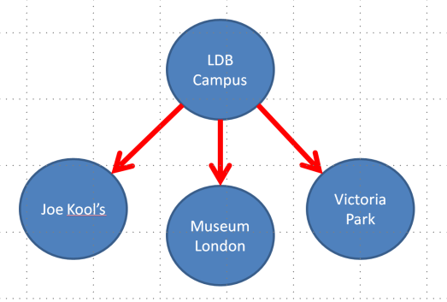
Make a program that loads the values into each of these nodes, and “connect them together”. This would be where cParent and cChildNodes are pointed to other nodes. In the diagrams below, the circles are the nodes, and the arrows indicate the pointers connecting “parent to child”.
You can do this in whatever way you’d like, but I’d suggest it be based on “closest location”. This is somewhat up to you, so you could do the 1st 4 items this way
(where you can get to all three locations from the LDB campus, but if you wanted to go from “Joe Kool’s” to “Victoria Park”, you would have to go to “LDB Campus” 1st.)
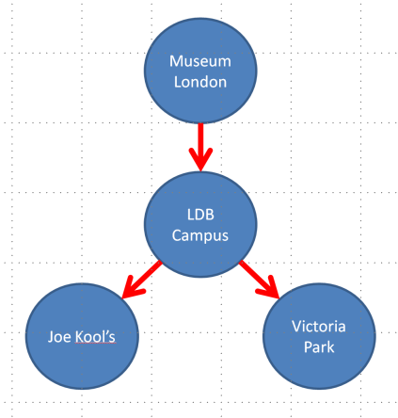
Or this way...

(Where to get to the “LDB Campus”, you’d have to go to “Museum London” 1st)

Or some other way!
BUT it must be a tree not a list. Like you can’t just list them one after another; as much as possible, you have at least a binary tree situation.
One way to think about this would be like bus stops, where you have to go from one stop to another to get somewhere. Like you wouldn’t have to get off the bus at every stop, but each stop would be announced as you drove along. But you couldn’t just “jump” from one end of the city directly to the other end of the city without going through all the stops in between.
Finally:
- Add some code that will navigate through your visit. In other words, when your program runs, it would print out all the places you’re going, in the order that you’d visit them.
The “catch” here is that you’ll have to backtrack up and down the tree. Like in the example above, if you wanted to visit “Museum London”, then “Joe Kool’s”, then “Victoria Park”, you will have to go through the “LDB Campus” a number of times.
- Once that’s done, add a new “stop” to visit, and update the code to show that.
- The navigating will have to be something that allows you to navigate around the tree structure. I’d suggest a few methods/functions like this:
  - MoveToChildNodeX(int nodeNumber)
    - Navigate to the specific child node of this (“current”) node.
  - MoveToParentNode()
    - Navigate to the parent of this (“current”) node.
  - GetDataAtNode()

2: Dem Bones
“Dem Bones” is a child’s tune that names off some of the bones in your body. Apparently, it was originally a Christian hymn, but we’re only going to look at the verses that involve the bones: https://en.wikipedia.org/wiki/Dem_Bones and https://www.youtube.com/watch?v=pYb8Wm6-QfA
This option is to mimic a “scene graph” or the “bones” in a “skinned mesh animation” character.
The “node” would be the specific bone, and the connections are the pointers to the next node.
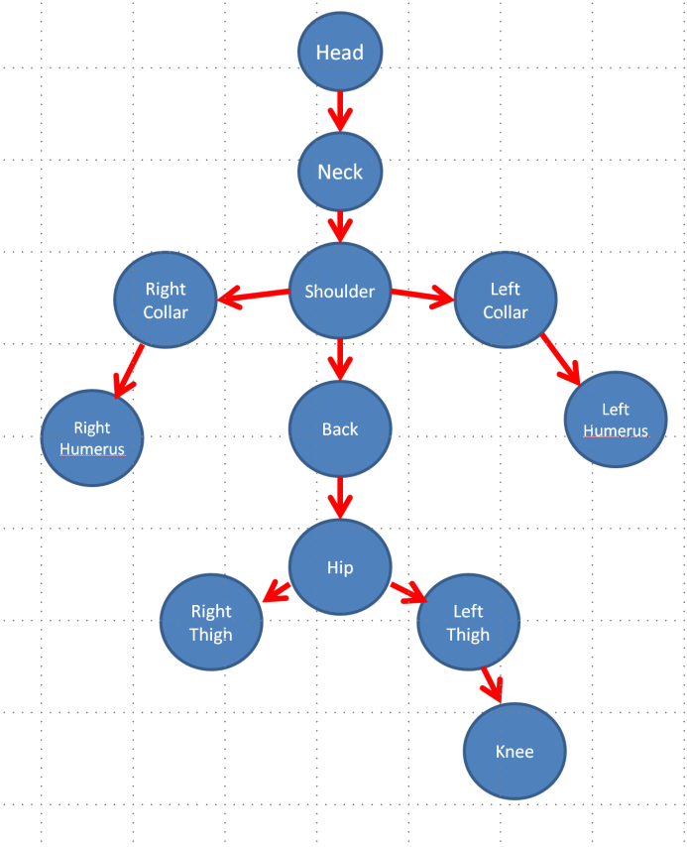
Here’s the first few lines:
- Head bone connected from the neck bone
- Neck bone connected from the shoulder bone
- Shoulder bone connected from the back bone
- Back bone connected from the hip bone
- Hip bone connected from the thigh bone
- ...and so on
Set up your nodes like this tree
(it doesn’t have to be identical, but it’s laid out like a person’s skeleton)
So the “data” for each node would be the name of the bone (“Head”, “Neck”, “Hip”, etc.), and the connections would be the pointers going from one bone to the other (the “...connected from the...” part of the song).
By navigating from one node (bone) to another, print out the lyrics to the song (or an abbreviated version).
Note that one of the verses goes “down” the list of bones (head to foot), then the other verse goes “up” the bones (foot to head).
The navigating will have to be something that allows you to navigate around the tree structure. I’d suggest a few methods/functions like this:
MoveToChildNodeX(int nodeNumber) // or maybe (string nodeName) as a parameter
Navigate to the specific child node of this (“current”) node.
MoveToParentNode()
Navigate to the parent of this (“current”) node.
GetDataAtNode()

